25.57: a) The current must be the same in both sections of the wire, so the current in the thin end is 2.5 mA.
b) 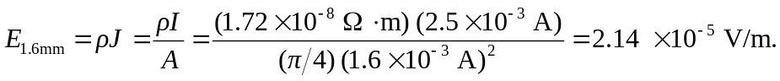
c) 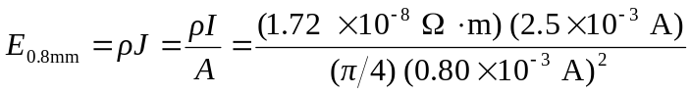
=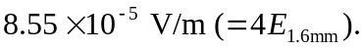
d) 